Sawyer's Landing
!Seat 1: Sidney Atzmon (C.
!Seat 2: Alben Duffie (V.C
!Seat 3: Bryan Finnie (A.S
!Seat 4: Ro_g_er LeBlanc (A.S
!Seat 5: William Fleck (A.S

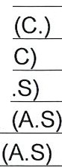

Community Development District
Agenda

Wednesday February 9, 2022
10:00 a.m.
Bethel A.M.E. Church, Inc, Lightburn Building,
245 NW 8th St., Miami, FL 33032
https://global.gotomeeting.com/join/138969901
+1 (872) 240-3212; Access Code: 138-969-901

- Roll Call

- Approval of Minutes of the October 13, 2021 and December 22, 2021 Meetings

- Consideration of Resolution #2022-01 Approving the Proposed Fiscal Year 2023 Budget and Setting the Public Hearing

- Consideration of:
  - Engagement Letter with Greenberg Traurig - Brownfield Related

  - Revised Engagement Letter with Grau & Associates to perform the Audit for Fiscal Year Ending September 30, 2021

- Ratification of:
  - Third Party Consent and Amendment
    - Development Service Agreement - Colony Development Services LLC.

    - Certified Arborist Assessment and Tree Permitting Services- New Leaf Environmental, LLC.

    - Architectural Services Agreement -Arquitectonica International Corporation

    - Partial Assignment of Accessibility Consulting Services - Accessibility Consulting, LLC.

    - Network Services Consulting- Network Cabling Consulting Services- Security Consulting Services Security, AV and Wi-Fi System Services - Security Innovative Solutions, Inc. dba System Integrated Solutions

    - Elevator Consultant Agreement - Persohn/Hahn Associates, Inc.

    - Environmental Signage and Graphic Design Services Agreement - TGA Design

    - Structural Peer Review Services Agreement - Frank Prietro, P.E.

    - Parking Garage Functional Design Services, Parking Garage Consulting Services, Parking Garage Pedestrian Warning System Services - Walker Parking Consultants/ Engineers, Inc.

    - ALTA Survey Report Agreement- Ford, Armenteros & Fernandez, Inc.

    - Pre-Construction Condition Survey and Vibration Monitoring Services Agreement - NV5, Inc.

    - Construction Scheduling and Reporting Services Agreement - Gary Draper & Associates of Atlanta, Inc.

    - Video Existing Sanitary Sewer Services Agreement - City Engineering Contractors, Inc.

    - Threshold Inspections Services Agreement - De Los Reyes Engineering, Inc.

    - Services Agreement- Clark Cook
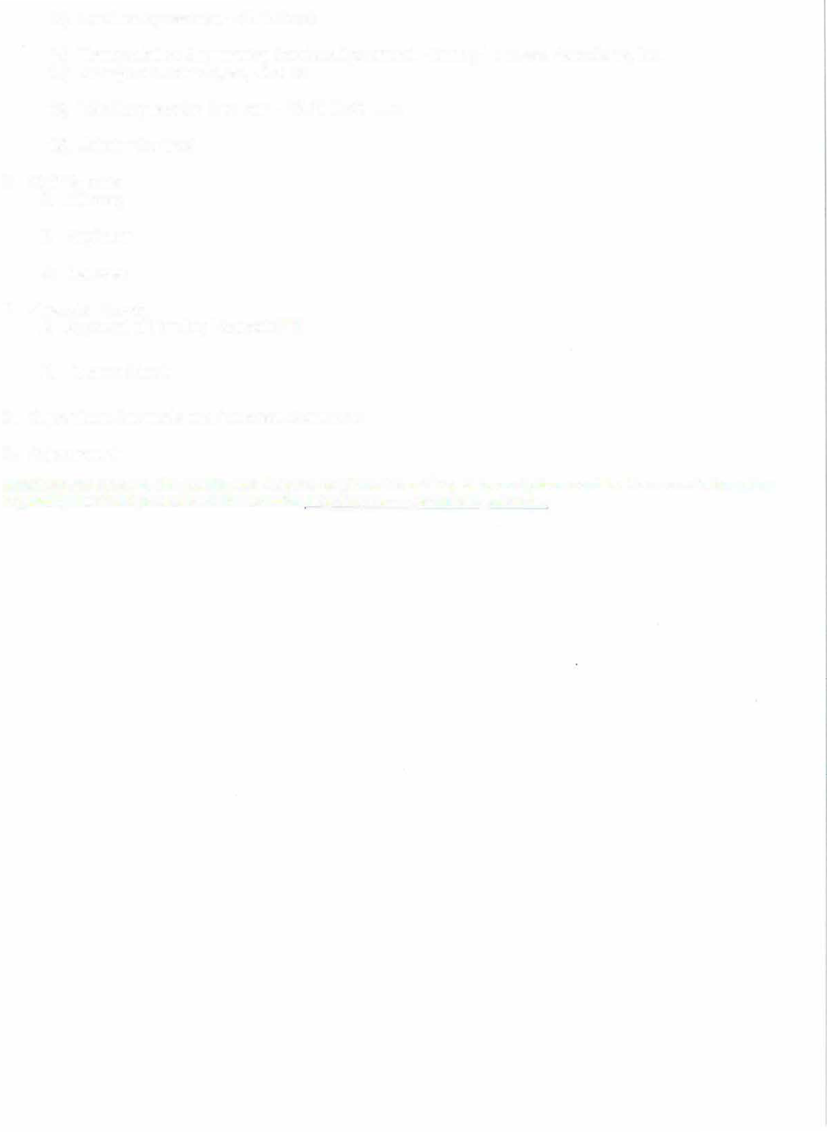

    - Transportation Engineering Services Agreement- Kimley-Horn and Associates, Inc.

    - Change of Order #2, #3, #4 & #5
    - Wind Engineering Services- RWDI USA, LLC

    - Joinder Contract
- Staff Reports
  - Attorney

  - Engineer

  - Manager
- Financial Reports
  - Approval of Funding Request #11

  - Balance Sheet

- Supervisors Requests and Audience Comments

- Adjournment
Meetings are open to the public and may be continued to a time, date and place certain. For more information regarding this CDD please visit the website: http://www.sawyerslandingcdd.com

